# **Rugged**ThermocoupleThermometer Kit-(Type K Probe)



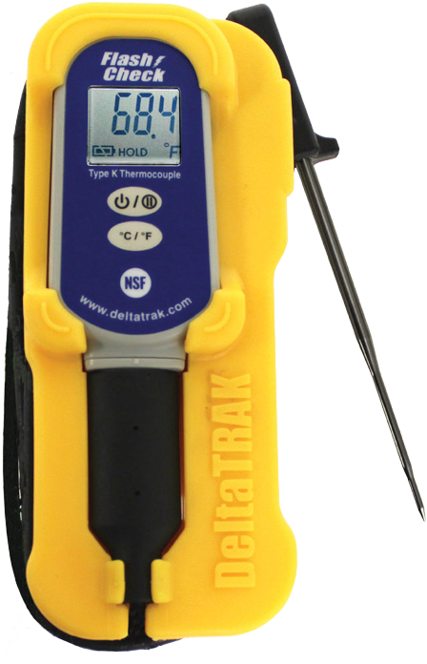

Model 25050

Probe with reduced tip

* 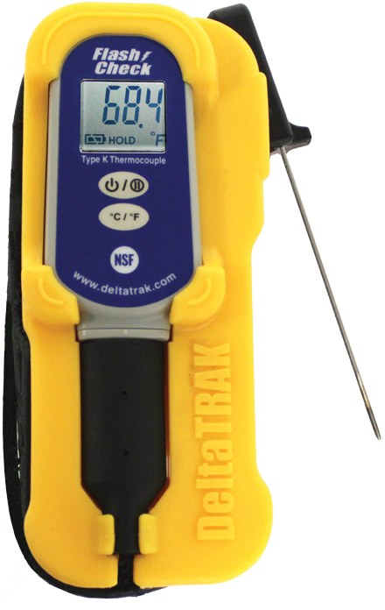Calibrating Pat allows adjustingtemperature ranges for more accurate readings

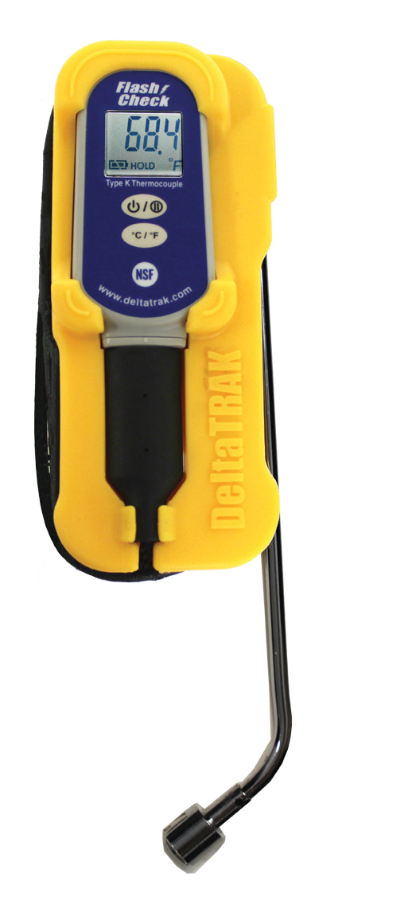

Model 25051

with surface probe

|  |  |
| --- | --- |
| Measuring range (probe) | -76 ° F to 1112°F(-60 ° C to 600°C),  dependent upon probe |
| Scope of work(basic unit) | 32°F to 122°F (0°C to  50°C） |
| display resolution | 0.1°F/°C 33.6 to  391.8°F (-9.9 to  199.9°C), 391.9°F (200°C) above 1.0°F/°C |
| precision | ±1% of reading or1.8°F (1°C), whichever is greater, ranging from-4 ° F to 284°F (-20 ° C to  140°C）。2% of readings |
| Battery/life | CR2032 lithiumbattery/100 hours continuous use |
| Body size | 3 x 1.7 x 0.8 inches (78 x)  42 x 20 mm) |
| weight | 1.42 ounce (40.15  g), includingbatteries |
| authentication | CE Mark, NSF |
| IP rating | IP54 splash proof |

* Ruggedprotective rubber housing
* Ideal for food service and quality control inspectors
* NSFcertification
* Switchable °F/°C
* Three interchangeableK probes available
* LargeLCD display
* IP54 splash proof

Kit includes 25003 base unit, protective cover and 1 probe. Additional probes are sold separately.

Model 25052

probe with needle

Thermometers andprobes are also available separately.



SS 25050-X Page 1 of 2 17 I1 

DeltaTrakregisteredquality management systemaccording to ISO9001:2008

**rugged**

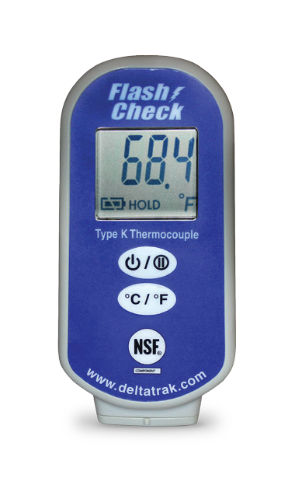

Model 25003

elementary unit



# K-probe

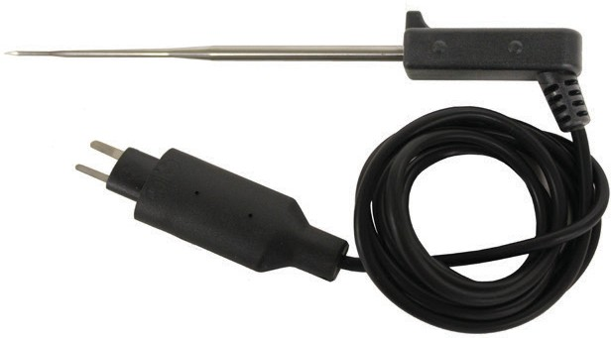

Model 25054

Reduced Tip Probe

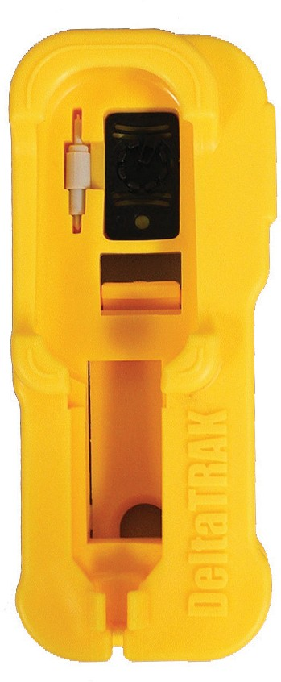

(4 "long, 101.6mm, tip diameter 2.33mm w/39.56mm cable)

-76 ° F to 752°F (-60 ° C to 400°C)

(7.5"Long, 190 mm w/39.56 mm cable)

-76 ° F to 752°F (-60 ° C to 400°C)

EMC/RFI: If the unit is in radio range

The frequency electromagnetic field strength is about 3 volts per meter, but the performance of the instrument is not permanently affected.

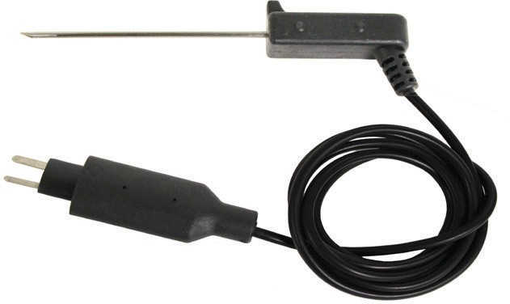

Model 25056

needle probe

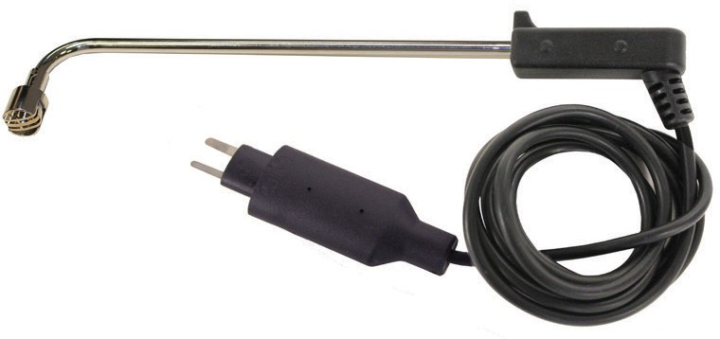

Model 25055

surface probe

Model 25053

rubber housing

(4.4"Long, 112 mm, tip diameter 1.6 mm w/39.56 mm cable)

-76 ° F to 1112°F (-60 ° C to 600°C)

SS 25050-X Page 2 of 2 17 I1

